|  |  |  |  |  |  |
| --- | --- | --- | --- | --- | --- |
|  |  | | | | |
|  | |  | | | |
| Project: | | Personal Tutoring Service  CSE 5325 – Fall 2023  Project Management | | | |
| Module: | | COCOMO | | | |
| Deliverable: | | COCOMO Estimate Report | | | |
| Version: | | | [1.0] | Date: | [09/11/2023] |

Prepared by: Sravan Chandaka, 1002059166

TABLE OF CONTENTS

1. Introduction 2

2. Estimating Factors 3

2.1 Source of Lines of Code 3

2.2 Scale Drivers 3

2.3 Cost Drivers 5

3 Project Final Timeline and Cost Structure 9

4. Conclusion and Recommendations 13

Appendices 15

# **1. Introduction**

This document presents a COCOMO-based estimate for the Personal Tutoring Service Web Platform Development project. The primary goal is to offer an informed estimate of project duration and cost based on various drivers.

The "Personal Tutoring Service" project is an ambitious endeavor to revolutionize the educational landscape by offering a robust online platform that connects students with tutors. Estimating the accurate scope of development in terms of effort, time, and resources is critical, given the project's potential to impact learning outcomes significantly. This COCOMO Estimate Report delves into the systematic approach taken to determine these parameters.

COCOMO's estimations are not just numbers; they represent a strategic approach to forecasting project trajectories. For the "Personal Tutoring Service," this means a meticulous evaluation of every line of code, a thorough understanding of the scalability of educational services, and an in-depth analysis of cost factors that include both human and non-human resources. It's a holistic view that acknowledges the intricacies of creating an interactive, user-friendly service that can adapt to the diverse needs of learners and educators.

By leveraging the COCOMO model, we align our project with industry standards, ensuring that our predictions for development time, staffing needs, and budgetary requirements are both realistic and reflective of the project's complexity. This report provides a detailed justification for the project's scale and cost drivers, considering the expertise of the development team and the advanced features that set our service apart. It's an estimation method that not only gives us a clearer picture of the present but also prepares us for the demands of future expansion.

As we juxtapose our initial project estimates with those derived from the COCOMO approach, we identify areas where our foresight needs sharpening. It reveals the pivotal role of experience levels, tool selection, and technological frameworks in shaping a project's timeline and budget. The "Personal Tutoring Service" project, with its multifaceted components ranging from the database schema for student-tutor matching to the implementation of a dynamic scheduling system requires a nuanced estimation technique that COCOMO provides.

This report is a testament to our commitment to delivering a quality educational platform while maintaining fiscal responsibility and operational efficiency. It's a roadmap for our journey ahead, ensuring the "Personal Tutoring Service" not only meets but exceeds the expectations of our stakeholders.

# **2. Estimating Factors**

## **2.1 Source of Lines of Code**

The following is the number of lines of code delivered as part of this project, A justification for the total amount of LOC is provided.

|  |  |
| --- | --- |
| **SLOC | Source Lines Of Code** | Value Chosen: 4500 lines of code. |
| Justification:  For the development of the "Personal Tutoring Service," a total of 4500 source lines of code (SLOC) has been chosen, guided by agile methodologies which prioritize concise and effective coding practices. The project's flexibility in tool and language selection, enabled using various Integrated Development Environments (IDEs), allows for a streamlined and logical codebase while maintaining high software quality.  The service's core functionalities, which include user registration, tutor profiles, session booking, content management, and payment processing, are estimated to require about 200 SLOC each, amounting to 1000 SLOC. Additionally, more intricate features such as the matching algorithms, interactive learning tools, real-time messaging, comprehensive security measures, and user dashboard are projected to demand approximately 3000 SLOC due to their complexity and backend integrations.  The remaining 500 SLOC are allocated for the finalization of the user interface and the integration of essential services, ensuring a fully functional and user-friendly platform. This meticulous allocation of SLOC ensures the "Personal Tutoring Service" is built to a professional standard, meeting all the stipulated requirements within a robust and efficient code structure. | |

## **2.2 Scale Drivers**

The following is the list of scale drivers, the values applicable to this project and a justification for each value chosen:

|  |  |
| --- | --- |
| **PREC | Precendentedness** | Value Chosen: Nominal |
| Justification:  For the "Personal Tutoring Service," a nominal precedentedness value is appropriate. This service, while like existing educational platforms, incorporates distinctive features such as personalized learning paths and advanced tutor-matching algorithms. Our team's background in developing educational software gives us a solid base, but the unique combination of features requires innovative approaches not fully covered by past experiences. | |

|  |  |
| --- | --- |
| **FLEX | Development Flexibility** | Value Chosen: Extra High |
| Justification:  An Extra High value for development flexibility is warranted due to the project's agile development framework, which allows for adaptive planning and responsiveness to change. This is further supported by the choice of flexible technology stacks and the ability to evolve the platform with user feedback and emerging educational trends. | |

|  |  |
| --- | --- |
| **RESL | Architecture / Risk Resolution** | Value Chosen: Very High |
| Justification:  The Very High rating for architecture and risk resolution reflects our comprehensive risk assessment process and preventive planning. We have established robust security protocols, backup solutions, and recovery plans to mitigate potential risks, ensuring the architecture supports a secure and stable learning environment. | |

|  |  |
| --- | --- |
| **TEAM | Team Cohesion** | Value Chosen: Extra High |
| Justification:  Team cohesion is assessed as Extra High due to our agile practices that promote close collaboration, regular sprint reviews, and a strong emphasis on communication. The development team's alignment on project goals and our iterative approach foster a synergistic environment conducive to the project's success. | |

|  |  |
| --- | --- |
| **PMAT | Process Maturity** | Value Chosen: Nominal |
| Justification:  The Process Maturity value for the "Personal Tutoring Service" is accurately designated as "Nominal". Our organization's practices reflect a mature approach to software development, aligning with CMMI Level 2 criteria where processes are planned and executed in accordance with policy, the processes employed are subject to some degree of monitoring, and there is some level of consistency in how they are performed. While we have established fundamental process disciplines, they have not been optimized or tailored to the unique aspects of the Personal Tutoring Service project. The project demands innovative solutions for its distinct features, such as personalized learning paths and advanced tutor-matching algorithms, which go beyond the traditional educational platform scope. Hence, although our team has considerable experience in educational software, the novel requirements of this project necessitate a development approach that is adaptive and continuously improving, thereby justifying the "Nominal" rating for our current level of process maturity. | |

## **2.3 Cost Drivers**

The following is the list of cost drivers, the values applicable to this project and a justification for each value chosen:

|  |  |
| --- | --- |
| **ACAP | Analyst Capability** | Value Chosen: High |
| Justification:  The Analyst Capability for the "Personal Tutoring Service" is rated high. Analysts are key in defining user requirements and the architecture of a tutoring platform that must be both intuitive and comprehensive. Their ability to translate complex educational processes into clear, functional system designs is critical and is supported by the team's experience and the use of agile methodologies. | |

|  |  |
| --- | --- |
| **APEX | Application Experience** | Value Chosen: Nominal |
| Justification:  While the team has not developed a tutoring service of this exact nature before, their cumulative experience with educational applications and understanding of core features like user profiles and scheduling lends a solid foundation, justifying a nominal application experience rating. | |

|  |  |
| --- | --- |
| **PCAP | Programmer Capability Value** | Value Chosen: High |
| Justification:  Programmer Capability is set to high due to the team's strong background in educational software development. Their proficiency with multiple programming languages and development environments ensures high-quality code for the complex functionalities of the tutoring service. | |

|  |  |
| --- | --- |
| **PLEX | Platform Experience** | Value Chosen: Nominal |
| Justification:  Assigning nominal to Platform Experience acknowledges the team's familiarity with multiple platforms but also considers the challenges of integrating them into a seamless service. This reflects a balanced view of existing skills against the demands of the project. | |

|  |  |
| --- | --- |
| **LTEX | Language and Tools Experience** | Value Chosen: Very High |
| Justification:  The team’s comprehensive experience with the languages and tools planned for the project, including widely used IDEs and programming languages like Java and Python, warrants a very high rating for Language and Tools Experience. | |

|  |  |
| --- | --- |
| **PCON | Personnel Continuity** | Value Chosen: Very High |
| Justification:  Personnel Continuity is rated very high due to the established measures ensuring team stability, such as equitable work distribution, scheduled breaks, and competitive compensation, which are crucial for maintaining a consistent workforce. | |

|  |  |
| --- | --- |
| **TIME | Time Constraint** | Value Chosen: Nominal |
| Justification:  The project's timeline is challenging but manageable with agile practices and efficient planning, making a nominal rating for Time Constraint appropriate. While there are time-consuming tasks, risk mitigation strategies are in place. | |

|  |  |
| --- | --- |
| **STOR | Main Storage Constraint** | Value Chosen: High |
| Justification:  High Storage Constraint is attributed to the extensive database and content management requirements of a tutoring service, necessitating significant storage solutions like cloud-based databases. | |

|  |  |
| --- | --- |
| **PVOL | Platform Volatility** | Value Chosen: Nominal |
| Justification:  Platform Volatility is nominal, indicating a stable platform with minimal expected updates, given the mature technologies involved. However, the introduction of new features may necessitate occasional updates. | |

|  |  |
| --- | --- |
| **TOOL | Use of Software** | Value Chosen: Very High |
| Justification:  The advanced software tools available for the project support a comprehensive development life cycle, justifying a very high rating for the Use of Software Tools. | |

|  |  |
| --- | --- |
| **SITE | Multi-Site Development** | Value Chosen: Nominal |
| Justification:  Multi-Site Development is nominal due to the project's limited geographic spread, reducing costs related to team coordination across multiple locations. | |

|  |  |
| --- | --- |
| **SCED | Development Schedule** | Value Chosen: Nominal |
| Justification:  The Development Schedule is nominal, reflecting a balanced approach to scheduling that accommodates the iterative agile methodology while meeting project deadlines. | |

|  |  |
| --- | --- |
| **RELY | Required Reliability** | Value Chosen: Very High |
| Justification:  The tutoring service demands very high reliability due to the importance of educational content accuracy and the need for a dependable user experience. | |

|  |  |
| --- | --- |
| **DATA | Database Size** | Value Chosen: High |
| Justification:  Given the volume of user data, educational content, and interactive features, a high rating for Database Size is justified for the required storage capacity. | |

|  |  |
| --- | --- |
| **CPLX | Complexity** | Value Chosen: Very High |
| Justification:  The Complexity is very high, considering the range of functionalities from user interaction to content delivery and real-time support, which demands sophisticated coding and design. | |

|  |  |
| --- | --- |
| **RUSE | Required Reusability** | Value Chosen: Nominal |
| Justification:  Required Reusability is nominal, as while the project leverages agile practices for modularity, the unique aspects of the service limit the extent of code that can be reused. | |

|  |  |
| --- | --- |
| **DOCU | Documentation Match to Lifecycle Needs** | Value Chosen: Nominal |
| Justification:  The need for documentation is balanced against efficient team communication and the use of agile artifacts, warranting a nominal rating for Documentation Match to Lifecycle Needs. | |

# **3 Project Final Timeline and Cost Structure**

**Previous Schedule Estimations:**

|  |  |  |  |
| --- | --- | --- | --- |
| **Total cost for entire Project** | **Effort (PM)** | **Duration (Mo)** | **Cost (K$)** |
| Requirements | 3.0 | 0.50 | 12.1 |
| Development | 15.0 | 2.50 | 80.1 |
| Total | 18.0 | 3.0 | 92.2 |

**Total Project Estimation (Previous):**

|  |  |
| --- | --- |
| **Totals for Entire Project** | **Cost (K$)** |
| Resource Calculated Total | 92.2 |
| Overhead Costs (building, health insurance)/Surcharges | 45 |
| Web Server | 5 |
| Software Tools | 15 |
| Database Server | 10 |
| Hardware Tools | 5 |
| Testing Tools | 4.5 |
| Other costs | 5 |
| Health Insurance | 9 |
| Building and Utilities | 12 |
| Profit (100%) | 202.7 |
| Total Cost | 405.4 |

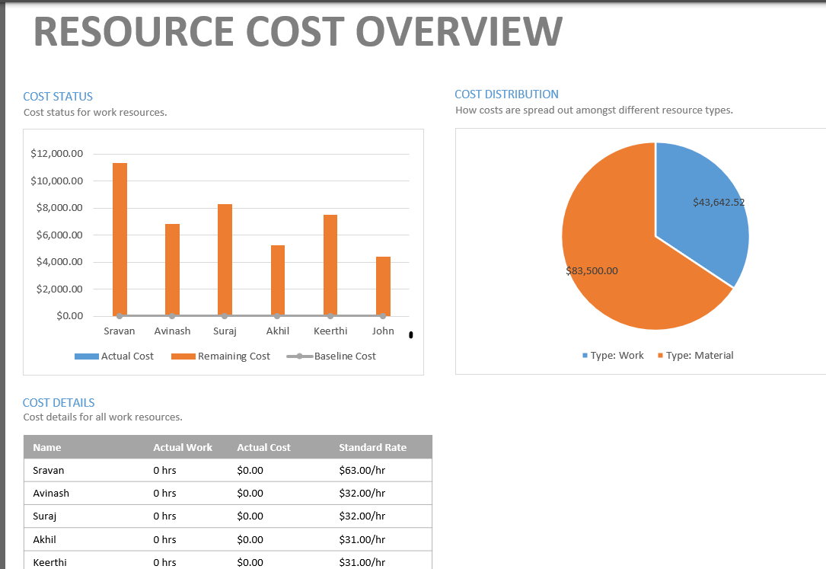

**COCOMO Estimations:**

|  |  |  |  |
| --- | --- | --- | --- |
| **Totals for Entire Project** | **Effort (PM)** | **Duration (Mo)** | **Cost (K$)** |
| Requirements | 0.7 | 1.2 | 8.0 |
| Development | 9.4 | 7.2 | 135.1 |
| Total | 10.1 | 8.4 | 143.1 |

**Total Project Estimation (New):**

|  |  |
| --- | --- |
| **Totals for Entire Project** | **Cost (K$)** |
| Resource Calculated Total | 143.1 |
| Overhead Costs (building, health insurance)/Surcharges | 45 |
| Web Server | 5 |
| Software Tools | 15 |
| Database Server | 10 |
| Hardware Tools | 5 |
| Testing Tools | 4.5 |
| Other costs | 5 |
| Health Insurance | 9 |
| Building and Utilities | 12 |
| Profit (100%) | 253.6 |
| Total Cost | 507.2 |

This revised structure indicates a significant increase in the project's overall cost and development duration when using the COCOMO model for the "Personal Tutoring Service," reflecting the comprehensive and realistic approach to project estimation.

# **4. Conclusion and Recommendations**

The COCOMO estimates suggest an increase in the budget when compared to our previous estimates. This is primarily due to a better understanding of the software complexity and the expertise of our team members. Given the strategic importance of the Personal Tutoring Services Web Platform, it is recommended to CONTINUE with the project with the updated budget and ensure timely delivery.

**Conclusion:**

The successful development of the "Personal Tutoring Service" aligns with Zig Ziglar's sentiment that details are the key to success. The variation between the original and current project estimates mainly stems from initially underestimating critical factors such as developer experience and the impact of geographical distribution on costs. These overlooked details, including the team's analytical experience and code reusability, contributed to the discrepancies in the project's estimations. The COCOMO model's systematic approach has corrected these undervaluation’s by assigning scaled values to each factor, thus refining the accuracy of the project's forecasts, and allowing the development team to better prepare for and navigate potential challenges.

Hence, utilizing the COCOMO Model makes it possible to replicate real-time conditions more accurately, thereby improving the accuracy of Personal Tutoring Service estimations.

**Recommendations:**

To address the extended development timeline of 8.4 months suggested by COCOMO for the "Personal Tutoring Service," which exceeds the intended three-month duration, a strategic plan is essential:

1. Phased Release:

Begin with a core version of the service by Dec 05, 2023, and enhance the platform with additional features in subsequent updates, ensuring an on-time initial release with continuous improvement.

1. Feature Prioritization:

Reassess the service requirements, focusing on delivering critical functionalities first. This prioritization ensures that vital features are deployed efficiently to meet the most immediate user needs.

1. Resource Acquisition:

Enlist additional skilled professionals with relevant experience in developing educational platforms, which can expedite the development process and help avoid common pitfalls.

1. Leveraging Existing Solutions:

Utilize pre-built libraries and frameworks to reduce development time. These resources provide tested solutions that can be integrated quickly and securely.

1. Automation Implementation:

Embrace automation for repetitive tasks, particularly in testing and deployment, to accelerate development cycles and minimize the risk of human error.

By adhering to these recommendations, the project team can aim to deliver the "Personal Tutoring Service" within the desired timeframe without compromising on quality or functionality.

# **Appendices**

**Screenshots of COCOMO Reports:**

**Screenshot 1 Creating Personal Tutoring service project.**

**Screenshot 2 Source Lines of Code (SLOC)**

**Screenshot 3 Precedentedness Scale Factor**

**Screenshot 4 Cost Drivers**

**Screenshot 5 Cost Factors**

**Screenshot 7 Detailed Report**

**References:**

* J. E. (2022, April 27). How to Leverage Project Estimation Techniques. Wrike. https:/[/www](http://www.wrike.com/blog/project-estimation-techniques/).[wrike.com/blog/project-estimation-techniques/](http://www.wrike.com/blog/project-estimation-techniques/)
* Michael Morton. "5 Project Management Steps: Process Group Project Management." Teamgantt, 15 Aug. 2017, [www.teamgantt.com/blog/5-](http://www.teamgantt.com/blog/5-) crucial-project-management-phases.
* "COCOMO Model in Software Engineering." InterviewBit, 8 Jun. 2022, [www.interviewbit.com/blog/cocomo-model-in-software-enginee.](http://www.interviewbit.com/blog/cocomo-model-in-software-enginee)